|  |
| --- |
|  |
| SR Access Provisioning Card Tool |
| Version 01.01.03 |

**Revision History**

|  |  |  |  |  |
| --- | --- | --- | --- | --- |
| **Version** | **Date completed** | **Written by** | **Reviewed by** | **Approved by** |
| 01.01.01 | 22/11/2018 | Abhishek Jogani |  |  |
|  | First Draft | | | |
| 01.01.02 | 27/11/2018 | Abhishek Jogani |  |  |
|  | Add Default Key and Provisioning Fail. | | | |
| 01.01.03 | 29/11/2019 | Abhishek Jogani |  |  |
|  | Remove Search TAG and make default COM port display. | | | |
|  |  |  |  |  |
|  |  | | | |
|  |  |  |  |  |
|  |  | | | |
|  |  |  |  |  |
|  |  | | | |

# Install Windows based Application

## Connect USB flash drive to PC and open “SR Access Provisioning Card Tool” folder.

Double click on “Setup” to run setup

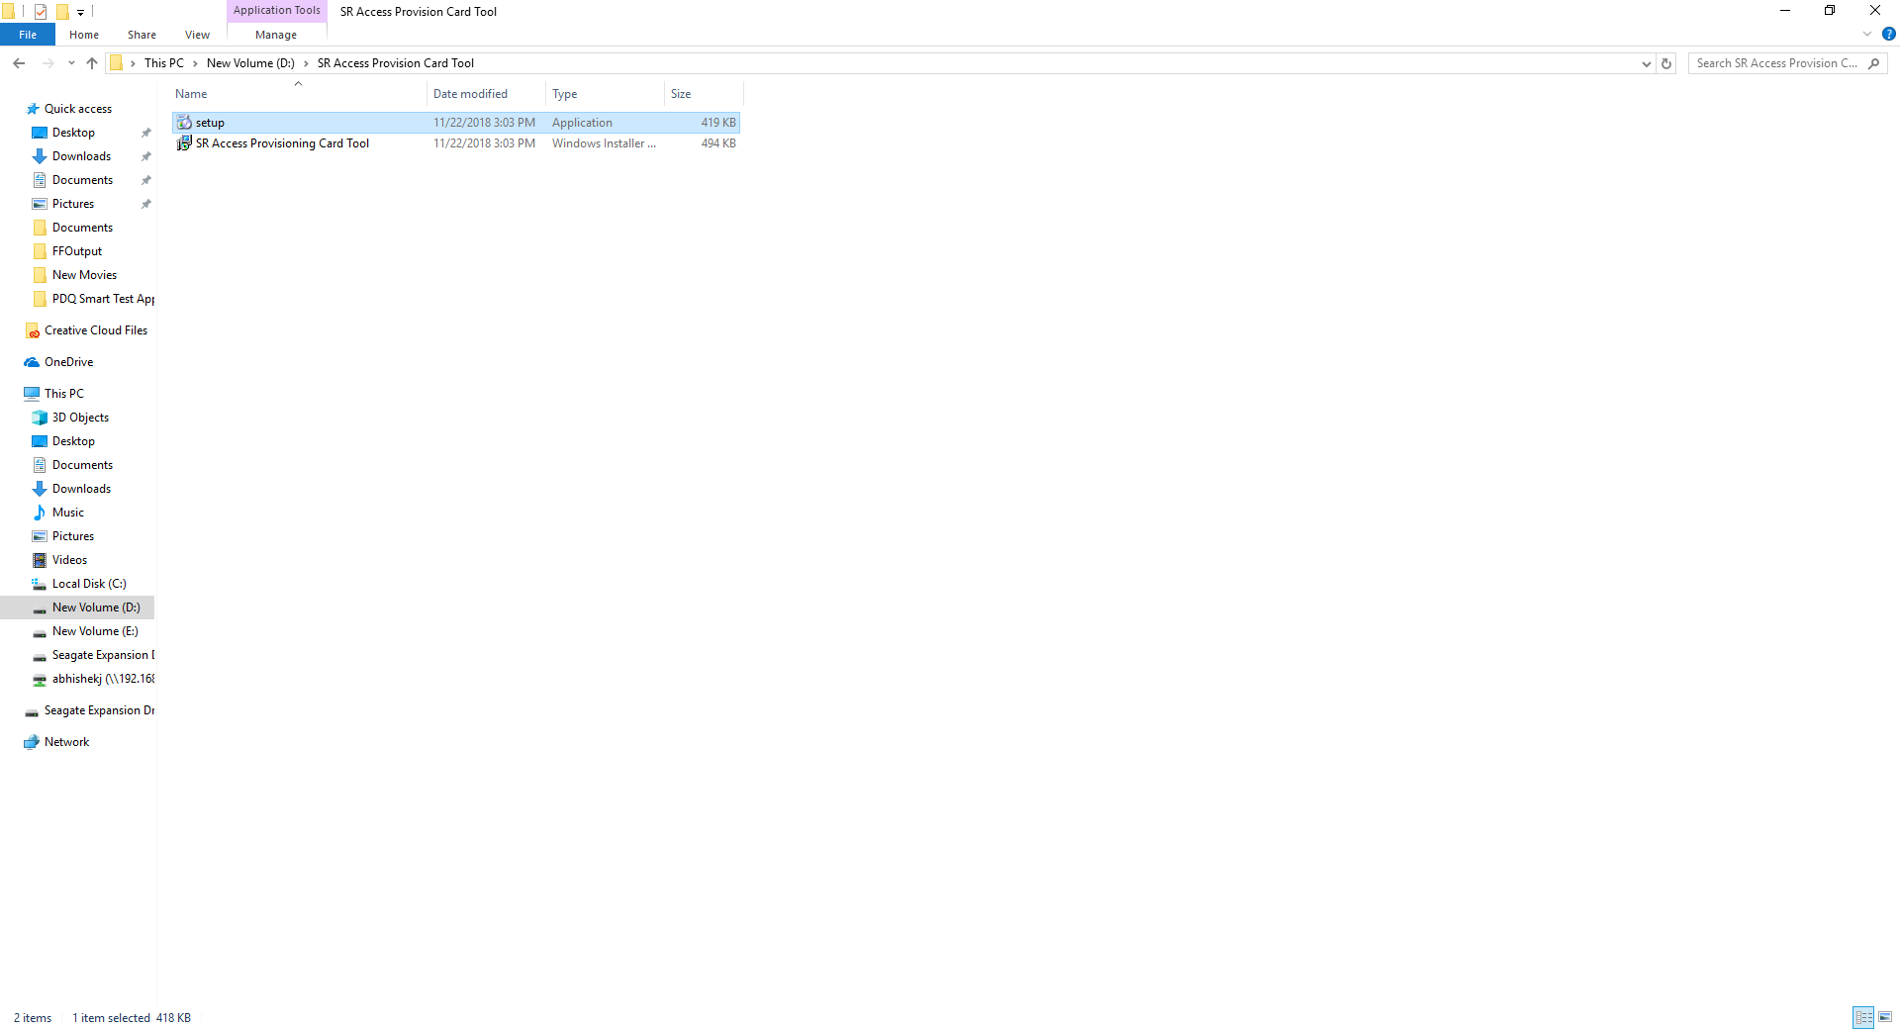

## Click “Next”

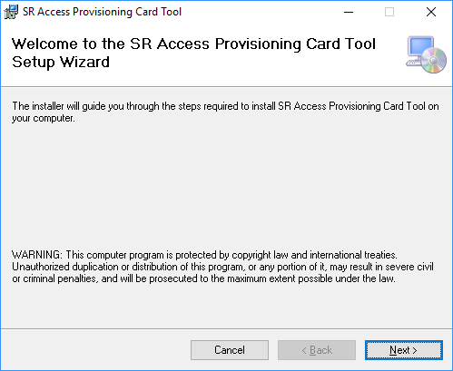

## Change installation path using Browse button if would like to install this application to different folder. Select Everyone option so any user on this PC can run this application

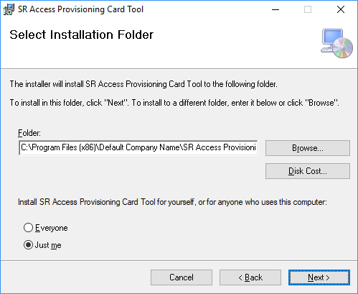

Click here to give access of this application to all users in this Computer

Click here to change installation path.

## Click **“Next”** to start Installing this application

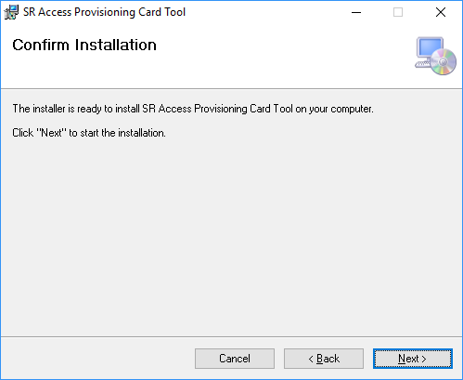

Click **“Next”** to start installing this application

## After Successful installation, Click **“Close”**

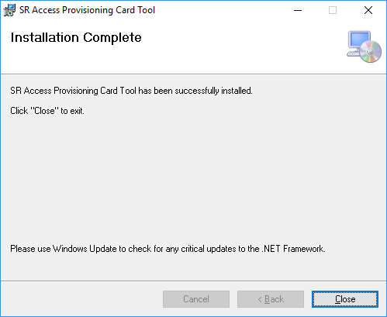

After Successful installation Click on **“Close”.**

# Provisioning of MiFare Card:

## Connect Elatec RFID card Reader to same PC where above application is installed

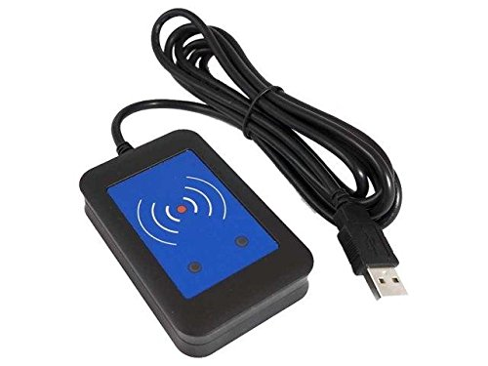

Plugin USB cable in System.

## Verify it is installed as USB COM port. To verify, open Device Manager and open **“Port (COM & LPT)”**

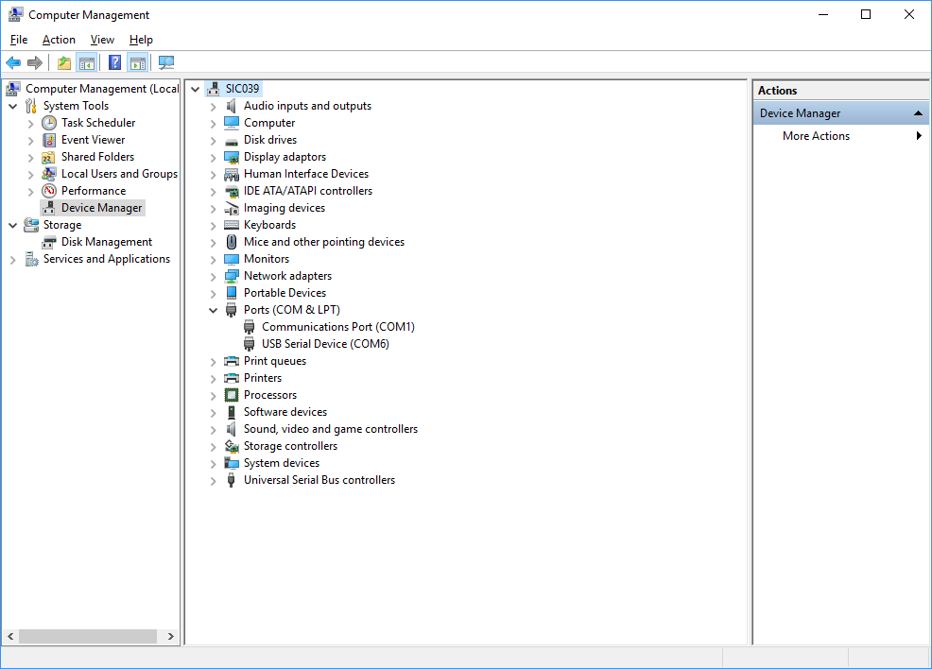

Elatec Device will connect as USB Serial Device

## Open “SR Access Card Provisioning Tool” available on desktop

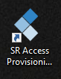

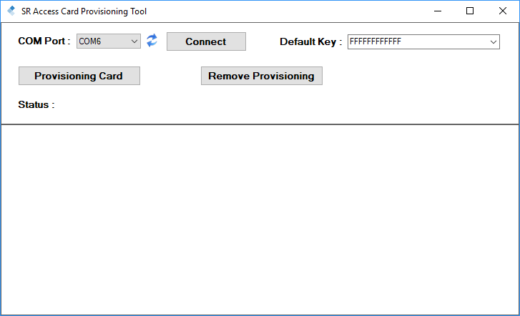

## Default COM port of the Elatech RFID Card Reader will Display in COM

## Port section area click on Refresh “**ICON”** and Click on “**Connect”**

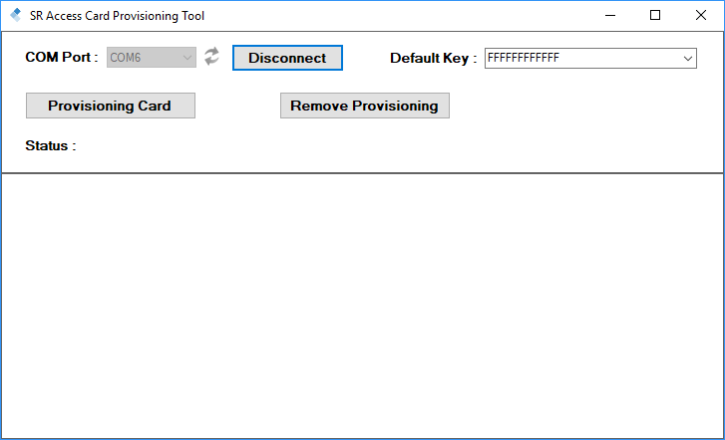

## Once COM port is connected, enter key provided by card manufacturer:

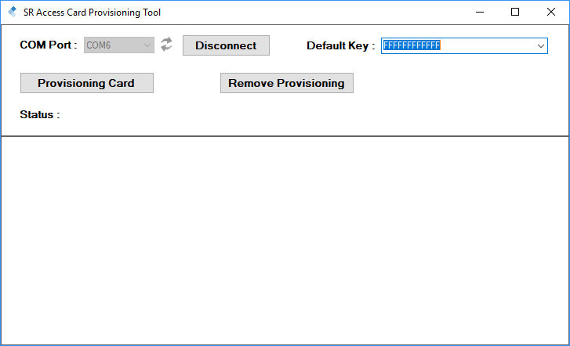

Enter Key provided by card manufacturer

## Once COM port is connected, place MiFare card on Elatec reader

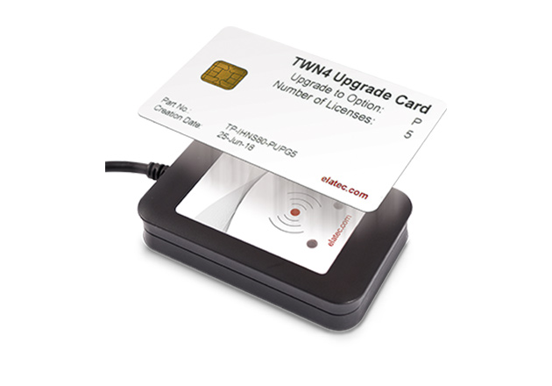

## Click **“Provisioning Card”.** If card is provisioned successfully, it will give

## success message in status field below. Make note of card # so it can be

## used to verify if needed

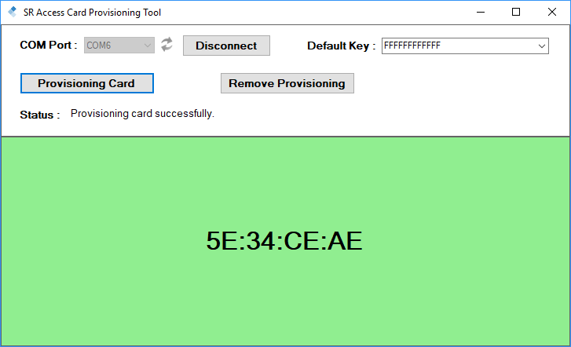

To clear content of card, click here

To provisioned card, click here

Provisioning successfully done

## If provisioning fails, clear card by selecting remove provisioning and try again. Also verify default key is correct

## 

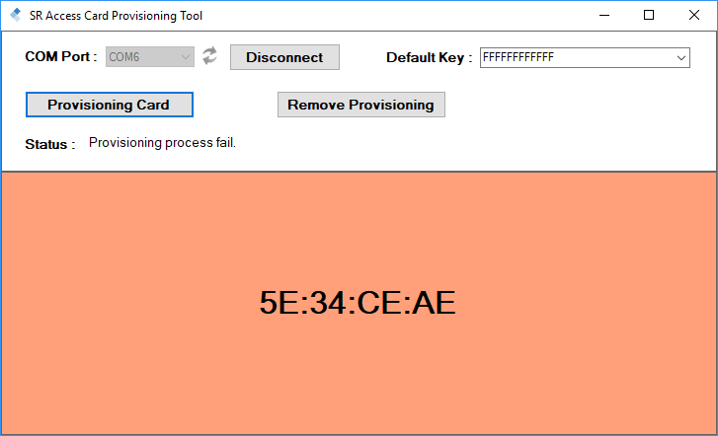

Click here to Remove Provisioning.

**Provisioning card Fail”**